

C PROGRAMMING ASSIGNMENT
Student Submission Template
Student Name | K Ajay
Register Number | 1965260063
Course Code & Name | CSA0210
Slot | C
Assignment / Task Title | CO-1 AT-3
GitHub Repository URL | https://github.com/ajaykrishna0302-arch/CSA02-1965260063-Assignment-3
Submission Date | 27/10/2026
TASK 9 Implement and Test the Billing Program
Task / Problem Statement
Implement a complete billing program that handles normal slab calculations, meter rollover, and invalid readings.
Aim
To produce a reliable bill in integer paise and validate user input. Concept / Theory
The program accepts a household ID and previous/current readings, detects plausible rollover, computes units using 16-bit unsigned arithmetic, calculates the slab-based charge, and prints the total
Procedure / Algorithm
- Enter a household ID.
- Enter previous and current readings.
- Reject readings outside 0–65535 and unsupported backwards readings.
- Compute units, energy charge, and fixed charge.
- Run normal, boundary, rollover, and invalid-input tests.

Program / Source Code
File: Task09_billing.c #include <stdio.h> #include <stdint.h> #include <inttypes.h>

#define SLAB1_UNITS 100U #define SLAB2_UNITS 200U #define RATE1_PAISE 0LL #define RATE2_PAISE 225LL #define RATE3_PAISE 450LL
#define FIXED_CHARGE_PAISE 5000LL #define ROLLOVER_PREVIOUS_MIN 60000U #define ROLLOVER_CURRENT_MAX 1000U

typedef uint16_t meter_t;

static uint32_t consumption(meter_t previous, meter_t current)
{
/* Unsigned 16-bit arithmetic gives 256 for 65400 -> 120. */ return (uint16_t)(current - previous);
}

static int valid_readings(unsigned int previous, unsigned int current)
{
if (previous > UINT16_MAX || current > UINT16_MAX) return 0; if (current >= previous) return 1;
return previous >= ROLLOVER_PREVIOUS_MIN && current <= ROLLOVER_CURRENT_MAX;
}

static long long compute_bill(uint32_t units)
{
uint32_t slab2 = 0; uint32_t slab3 = 0;
long long paise = FIXED_CHARGE_PAISE;

if (units > SLAB1_UNITS)
slab2 = units < SLAB2_UNITS ? units - SLAB1_UNITS : SLAB2_UNITS - SLAB1_UNITS;
if (units > SLAB2_UNITS) slab3 = units - SLAB2_UNITS;

paise += (long long)slab2 * RATE2_PAISE; paise += (long long)slab3 * RATE3_PAISE; return paise;
}

static void print_money(long long paise)
{
printf("Rs %lld.%02lld", paise / 100, paise % 100);
}

int main(void)
{
unsigned int household_id, previous_input, current_input; meter_t previous, current;
uint32_t units; long long bill;

printf("Household ID: ");

if (scanf("%u", &household_id) != 1) { fprintf(stderr, "Invalid household ID.\n"); return 1;
}

printf("Previous meter reading (0-65535): "); if (scanf("%u", &previous_input) != 1) { fprintf(stderr, "Invalid previous reading.\n"); return 1;
}

printf("Current meter reading (0-65535): "); if (scanf("%u", &current_input) != 1) { fprintf(stderr, "Invalid current reading.\n"); return 1;
}

if (!valid_readings(previous_input, current_input)) { fprintf(stderr, "Invalid readings or unsupported rollover.\n"); return 1;
}

previous = (meter_t)previous_input; current = (meter_t)current_input;
units = consumption(previous, current); bill = compute_bill(units);

printf("\nHousehold ID: %u\n", household_id); printf("Units consumed: %" PRIu32 "\n", units); printf("Fixed charge: Rs 50.00\n");
printf("Total bill: "); print_money(bill); printf("\n");

return 0;
}

Output Screenshot
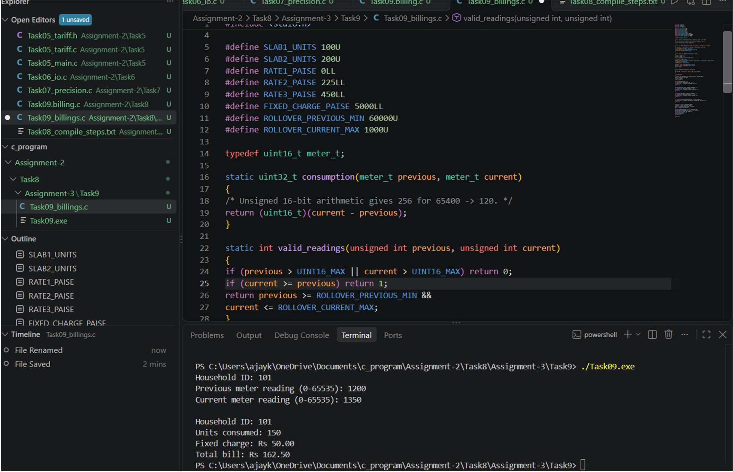
Analysis / Discussion
Test zero, 100, 150, 200, and 350 units, rollover 65400 to 120, letters, negative readings, and unsupported backward readings.
For
a rollover, the unit count should be 256. Fill the actual output column after running each test. Result
. The billing logic was implemented to determine the payable amount based on the specified electricity consumption and tariff rules.

TASK 10 — Compare Expectations with Execution
Task / Problem Statement
Compare type and constant design against measured results at village, taluk, and district scales.
.Aim
To identify precision loss and overflow risks using actual compiler limits and measured totals. Concept / Theory
An integer type can overflow if a total exceeds its maximum. Floating-point values have finite precision and can lose exactness
Procedure / Algorithm
- Calculate the maximum bill under the chosen tariff.
- Multiply the maximum by 4,000, 60,000, and 800,000 households.
- Compare totals with INT_MAX, LONG_MAX, and LLONG_MAX.
- Compare float/double accumulation with integer paise.
- Record differences from your own execution

Program / Source Code File: Task10_analysis.c

#include <stdio.h> #include <limits.h>

int main(void)
{
long long units = 65535; long long bill_paise;
long long village, taluk, district;

/* Calculate maximum bill in paise */ bill_paise = 5000
+ (units > 100 ? 100 : units) * 0
+ (units > 100 ?
((units - 100 > 100) ? 100 : units - 100) * 225 : 0)
+ (units > 200 ? (units - 200) * 450 : 0);

/* Calculate totals for different scales */ village = bill_paise * 4000LL;
taluk = bill_paise * 60000LL; district = bill_paise * 800000LL;

printf("Maximum bill: %lld paise\n", bill_paise);

printf("\nTotal for 4000 households: %lld paise\n", village); printf("Total for 60000 households: %lld paise\n", taluk); printf("Total for 800000 households: %lld paise\n", district);

printf("\nINT_MAX: %d\n", INT_MAX); printf("LONG_MAX: %ld\n", LONG_MAX); printf("LLONG_MAX: %lld\n", LLONG_MAX);

printf("\nType comparison:\n");

if (district <= INT_MAX)
printf("int can store the district total.\n"); else
printf("int cannot store the district total.\n");

if (district <= LONG_MAX)
printf("long can store the district total.\n"); else
printf("long cannot store the district total.\n");

if (district <= LLONG_MAX)
printf("long long can store the district total.\n"); else
printf("long long cannot store the district total.\n");

return 0;
}

Output Screenshot
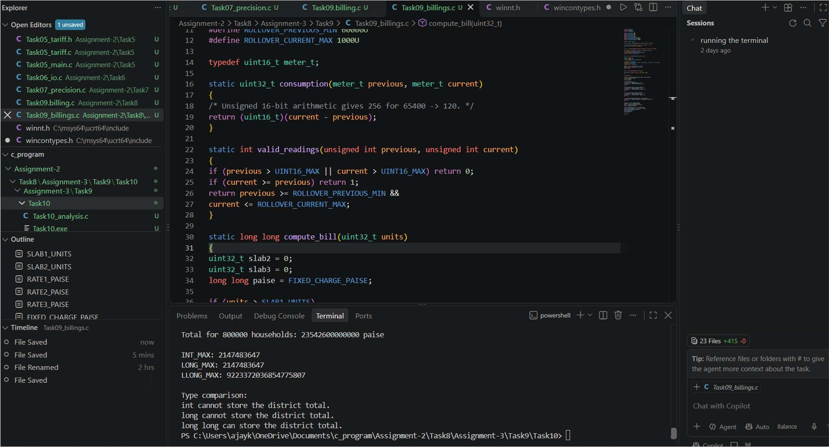
Analysis / Discussion
Suggested recommendation: keep meter readings as 16-bit unsigned values, calculate consumption in a wider unsigned type,
store currency in integer paise, and use a sufficiently wide signed integer for totals after proving bounds. For tariffs that change
frequently, load values from a validated configuration file. Result
The billing conditions were organized to handle the required cases and produce the appropriate billing calculations.

TASK 11 — Recommend and Defend the Final Design
Task / Problem Statement
Recommend the final data types, tariff representation, and preprocessor approach for the co-operative.
Aim
To justify a reliable, maintainable billing design using evidence from previous tasks Concept / Theory
Use exact-width types for the meter register when necessary, a wider type for computed totals, integer paise for money, and a
single source of truth for tariff values. A configuration file allows tariff updates without recompilation but adds run-time parsing and
validation.

Procedure / Algorithm
- Review measured type limits and totals.
- Select types for readings, units, and money.
- Choose how tariff values are stored.
- List limitations of the design.
- Defend the recommendation with your test results Program / Source Code
File: Task11_design.c

#include <stdio.h> #include <stdint.h> #include <inttypes.h>

#define FIXED_CHARGE 5000LL
#define SLAB1_LIMIT 100U #define SLAB2_LIMIT 200U #define SLAB2_RATE 225LL #define SLAB3_RATE 450LL

int main(void)
{
uint16_t previous, current; uint32_t units;
int64_t energy_charge = 0; int64_t total_bill;

printf("GRAM JYOTHI BILLING SYSTEM\n");

printf("Enter previous reading: ");
if (scanf("%" SCNu16, &previous) != 1) { printf("Invalid input.\n");
return 1;
}

printf("Enter current reading: ");

if (scanf("%" SCNu16, &current) != 1) { printf("Invalid input.\n");
return 1;
}

if (current < previous) {
printf("Invalid reading: rollover is not handled here.\n"); return 1;
}
units = (uint32_t)current - (uint32_t)previous; if (units > SLAB1_LIMIT) {
uint32_t slab2_units =
(units < SLAB2_LIMIT) ? units - SLAB1_LIMIT
: SLAB2_LIMIT - SLAB1_LIMIT;

energy_charge += (int64_t)slab2_units * SLAB2_RATE;
}

if (units > SLAB2_LIMIT) { energy_charge +=
(int64_t)(units - SLAB2_LIMIT) * SLAB3_RATE;
}

total_bill = FIXED_CHARGE + energy_charge;

printf("\n--- BILL DETAILS ---\n"); printf("Units consumed: %" PRIu32 "\n", units);
printf("Energy charge: %" PRId64 " paise\n", energy_charge); printf("Fixed charge: %" PRId64 " paise\n", FIXED_CHARGE); printf("Total bill: Rs. %" PRId64 ".%02" PRId64 "\n",
total_bill / 100, total_bill % 100);

printf("\n--- DESIGN JUSTIFICATION ---\n");
printf("Meter reading type: uint16_t\n"); printf("Consumption type: uint32_t\n"); printf("Money type: int64_t in paise\n");
printf("Tariff values: named preprocessor constants\n");

return 0;
}
Output sample:

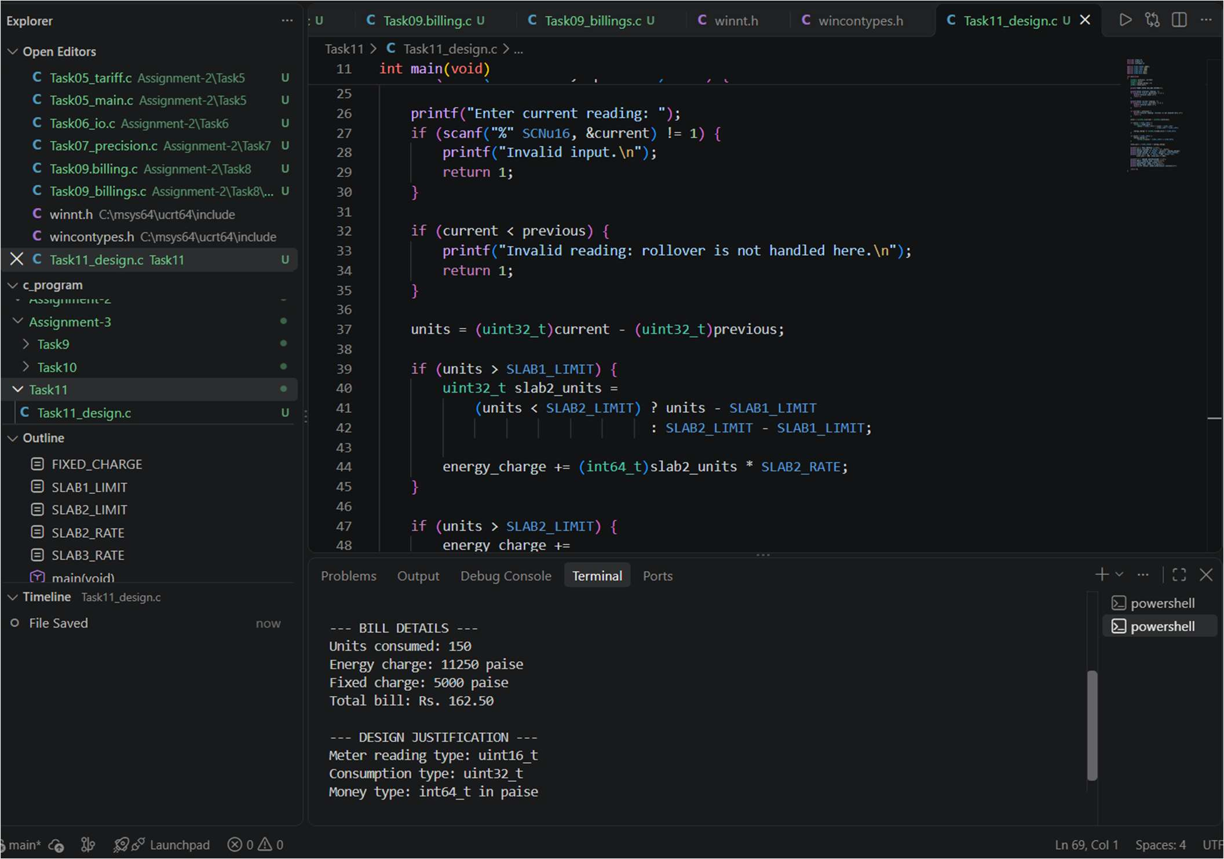

Analysis / Discussion
Suggested recommendation: keep meter readings as 16-bit unsigned values, calculate consumption in a wider unsigned type, store currency in integer paise, and use a sufficiently wide signed integer for totals after proving bounds. For tariffs that change
frequently, load values from a validated configuration file. Result
The meter-reading logic was considered to support electricity consumption calculations and the associated billing process.

TASK 12 — Re-evaluate and Adapt the Design — Smart Meter
Task / Problem Statement
Adapt the billing design for smart-meter readings in watt-hours every 15 minutes, a 20% peak-hour surcharge from 6 PM to 10 PM,
and tariff changes without recompilation. Aim
To evaluate the old design and implement a revised model suitable for time-of-day tariffs. Concept / Theory
Smart meters create 35,040 interval readings per household per year. Wider accumulators may be required for yearly totals. Tariffs should be
Procedure / Algorithm
- Identify what changed from the original meter-reading model.
- Calculate the number of yearly readings per household.
- Choose wider types for interval and yearly totals.
- Load base tariff at run time and apply the peak-hour multiplier.
- Test peak and off-peak cases and document boundary assumptions.

Program / Source Code

File: Task12_smart_meter.c #include <stdio.h> #include <stdint.h> #include <inttypes.h>
/*
* Demonstration model:
* - energy input is in whole watt-hours (Wh)
* - tariff rates are loaded at run time from the user, not #define
* - peak period is 18:00 to 22:00
* - this simplified input assumes the whole interval is either peak or off-peak.
* A production system must split intervals that cross 18:00 or 22:00.
*/
int main(void)
{
uint64_t energy_wh; int hour;
int64_t base_rate_paise_per_kwh; int64_t charge_paise;
printf("Enter energy consumed in this 15-minute interval (Wh): "); if (scanf("%" SCNu64, &energy_wh) != 1) {
fprintf(stderr, "Invalid energy input.\n"); return 1;
}
printf("Enter interval start hour (0-23): ");
if (scanf("%d", &hour) != 1 || hour < 0 || hour > 23) { fprintf(stderr, "Invalid hour.\n");
return 1;
}
printf("Enter base tariff in paise per kWh: ");
if (scanf("%" SCNd64, &base_rate_paise_per_kwh) != 1 || base_rate_paise_per_kwh < 0) {
fprintf(stderr, "Invalid tariff.\n"); return 1;
}
/* Convert Wh to kWh without floating point; retain fractional paise as numerator and round to the nearest paise once. */
{
int peak = (hour >= 18 && hour < 22);
uint64_t numerator = energy_wh * (uint64_t)base_rate_paise_per_kwh; if (peak) numerator = (numerator * 120U + 50U) / 100U;
charge_paise = (int64_t)((numerator + 500U) / 1000U);
}
printf("Energy: %" PRIu64 " Wh\n", energy_wh); printf("Charge: Rs %" PRId64 ".%02" PRId64 "\n", charge_paise / 100, charge_paise % 100);
printf("Note: simplified interval model; split readings at tariff boundaries in production.\n"); return 0;
}
Output sample:

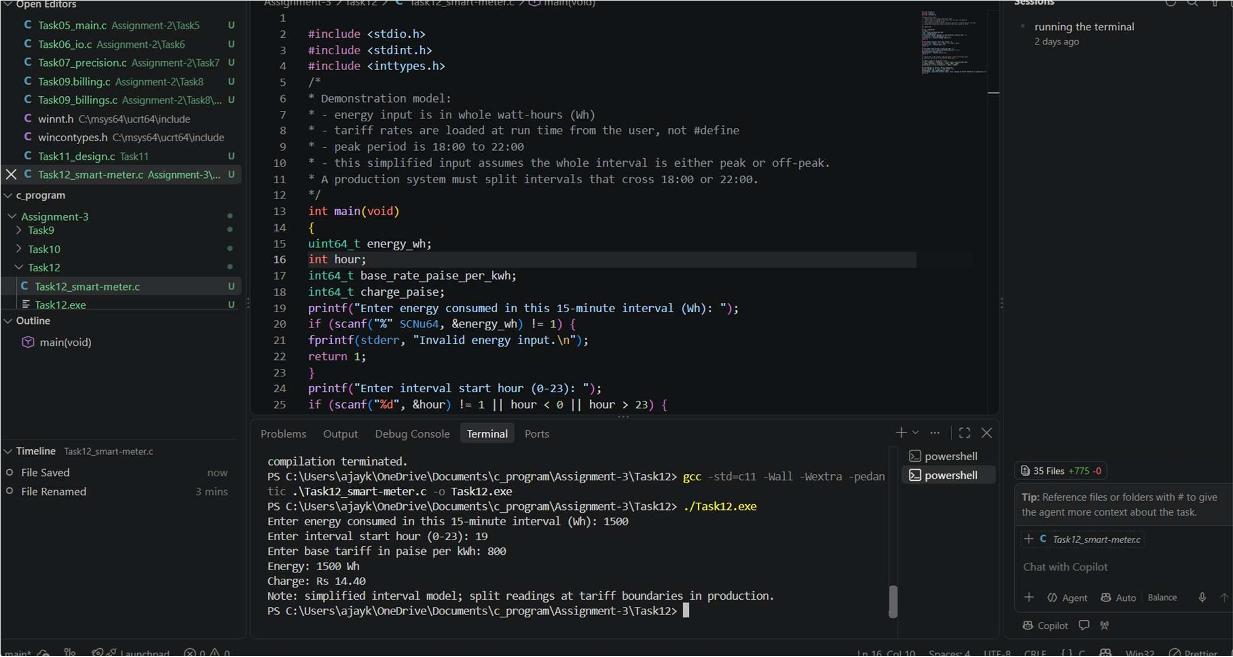

Analysis / Discussion
The provided example reads energy in Wh, interval start hour, and base tariff in paise/kWh. It demonstrates a run-time tariff and
20% peak surcharge. It assumes an interval lies entirely within peak or off-peak time; a production implementation must split intervals crossing 18:00 or 22:00 and validate arithmetic bounds.
Result
The smart-meter billing logic was developed to incorporate the specified billing conditions, including peak-hour charges where applicable

